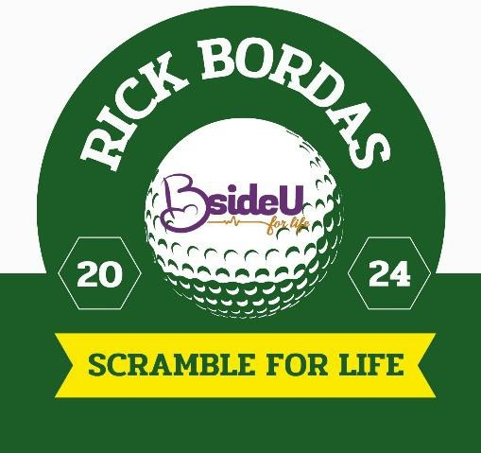

We would like to invite you to participate in the sixteenth annual “Rick Bordas Scramble For Life,” a fundraising golf
scramble in support of BsideU For Life, on Monday, May 6, 2024 at Audubon Country Club.
Our scramble is named in honor of Rick Bordas, who passed away in September of 2013 after a battle with cancer. Rick was instrumental in planning our initial Scramble For Life events, and we owe him a debt of gratitude for his selfless support of our ministry. It is our privilege to name the scramble after Rick to acknowledge his continued contribution in support of life, and to share our appreciation for this special man.
The goal of the Scramble For Life is to raise awareness and funds for this ministry that impacts the lives of thousands of women, men and their families each year. Because we don’t receive government funding, fundraising efforts like this, along with individual donations and church support, allow us to provide support and resources to those affected by unplanned pregnancies, walking beside them for life.
We are asking for your help by sponsoring our golf event. All of the sponsorship opportunities are shown on the attached page. We anticipate that 144 golfers (36 teams) from the community will attend this event so you can see how this sponsorship opportunity will benefit your business in terms of marketing and awareness.
Thank you in advance for joining with us!

Blessings,
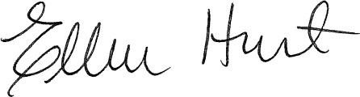
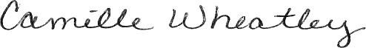
Ellen Hurt, Development Director Camille Wheatley, Asst. Development Director & Event Planner
ellen.h@bsideu.org camille.w@bsideu.org
Phone – 502-589-9400, ext. 102 Phone – 502-589-9400, ext. 103

BsideU For Life is a 501(c)3 nonprofit corporation. Your gift is fully tax deductible up to the limits of IRS regulations minus any goods or services you have received in whole or partial consideration for this support.The Federal Tax ID number of A Choice for Life, Inc., d/b/a BsideU For Life is 61-1142823.

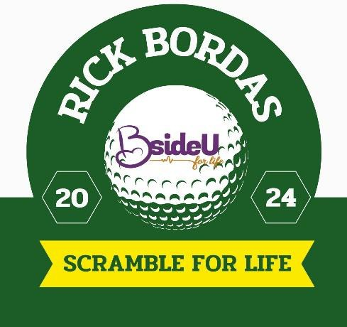
Audubon Country Club May 6, 2024
Registration opens at 11:00 a.m., (box lunches will be available) with Shotgun start 12:00 p.m. After golf, we have a great tasting grill out menu planned that will be available around 4:30 p.m.
YES! We want to partner with BsideU for Life (Please check the appropriate box below for team and sponsorship level):

Title - $10,000 Sold  X Sold to L&N Federal Credit Union | Meal Sponsor $2,000
Platinum - $5,000 | Sold Cart Sponsor $1,000 Sold
Gold - $3,000 | Sold Hole-in-One Sponsor $500 Sold
Silver - $2,000  Team One Golfer  $1,400 $350 | Putting Contest Sponsor $500  Hole/Tee Sponsor $200

NAME: _ TEAM:
ORGANIZATION/COMPANY: (As it should appear on signs)
MAILING ADDRESS: PHONE: FAX: EMAIL: _ WEBSITE:
I would like to fulfill my sponsorship by:
□ Check (enclosed) payable to “BsideU For Life”
□ MasterCard □ Visa □ AmEx
exp. date: /
Security Code
card # Name on card
□ Please send me a Sponsorship Invoice.
Initial sponsorship payments and Company Logo/Artwork are due no later than Apr 5, 2024 for Scramble for Life.
The form may be submitted on-line at https://www.bsideu.org/golf mailed to 701 W. Muhammad Ali Blvd Lou KY 40203 or emailed to camille.w@bsideu.org. Please contact Camille Wheatley at 502-589-9400 ext.103 for more information.

